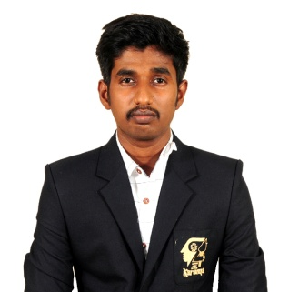**BALASIVAM. C**

NO 4, Melur road, 2nd street,

Sivaganga-630561.

Phone.no:8903649034

E-Mail:balasivam28@gmail.com

**CAREER OBJECTIVE**

Seeking a position with an organization which offers opportunities for my technical skills.

**EDUCATIONAL QUALIFICATION**

|  |  |  |  |  |
| --- | --- | --- | --- | --- |
| **Course** | **Institution** | **Year of passing** | **Board /**  **University** | **CGPA/ Marks %** |
| **B.TECH**  (FPE) | Karunya Institute of Technology and Sciences, Coimbatore. | 2021 | Deemed  University | 8.0 |
| **HSC** | Sambaviga Higher Secondary School, Sivaganga. | 2017 | State Board | 81.41% |
| **SSLC** | Oxford Matriculation Higher Secondary School, Sivaganga. | 2015 | Matriculation | 93.8% |

**KEY SKILLS**

HTML JAVASCRIPT NODEJS

CSS REACT JS **AREA OF INTEREST**

* WEB DEVELOPMENT

**COURSES COMPLETED**MERN STACK COURSE at GUVI GEEK NETWORKS IIT-M INCUBATED COMPANY.  
 **KEY STRENGTH**

* Adaptability
* Positive Attitude
* TimeManagement

**Experience:  
Frontend Developer**   
Thinkinfinity Technology pvt Ltd  
Chennai  
From 14.06.2023 to 30.11.2023

1. Developed and Maintained a comprehensive user management page enabling efficient user account creation, modification and deletion
2. Implemented Responsive Designs using HTML, CSS, JavaScript, Bootstrap  
   for different devices and screen sizes
3. Utilized Framework and Libraries are React.js for UI functionality and performance and Boostrap for create flexible and responsive layout ensure optimal user experience
4. Integrated APIs where frontend and backend with smooth interaction and optimized performance also implemented the CRUD Operations

**PERSONAL DETAILS**

Father’s Name : Mr. M. Chirchabai

Gender : Male

Nationality : Indian

Date of Birth : 28/01/2000

Languages Known : Tamil, English

Hobbies : Reading books